**CS155 Miniproject 2 – Eva L. Scheller and Eric Han**

**Introduction  
*Group members:*** Eva L. Scheller and Eric Han

***Team name:*** CaltechDanceTeam

***Division of labor***

Eva created basic visualizations of All Ratings, 10 most popular movies, and 10 best movies. Additionally, she implemented the surprise off-the-shelf implementation of matrix factorization in order to calculate error and create the 6 graphs associated with this method. Lastly, she analyzed visuals and wrote the report.

Eric created the basic visualizations of movies from the 3 different genres. Additionally, he implemented the homework 5 model with bias and without bias in order to calculate error and create 12 visualization graphs in association with these methods. Lastly, he implemented the projection of V into 2D-space.

General plotting functions and data loading functions were created by both group members in collaboration.

**Basic Visualizations**

Fig. 1 depicts the total number of ratings. Here we observe that the most common ratings are either 3 or 4 stars, while 1 or 2 stars are less common. This observations match with what we would have expected since people are generally most likely to give average/above average rating. Fig. 2 depicts the 10 most popular movies: Raiders of the Lost Arc, Independence Day, Air Force One, Toy Story, Scream, The English Patient, Liar Liar, Return of the Jedi, Fargo, and Contact. These appear to be movies that are either classics (e.g. The English Patient, Fargo) that have persisted through time, big Hollywood action movies (e.g. Air Force One, Independence Day), or part of a franchise (e.g. Indiana Jones, Star Wars, Toy Story). Hence, this appears to fit well with what we would have predicted to be the most popular movies. Interestingly, these movies are all from the 90’s or 80’s. This is probably helpful in order to have accumulated ratings on Netflix through time because these movies may have been there from the beginning.



Figure 1: Total number of ratings ordered by the number of stars.



Figure 2: The 10 most popular movies



Figure 3: Best rated movies.

Fig. 3 depicts the 10 best rated movies. We don’t recognize any of the titles for these movies, which is probably part of the reason that they have very high ratings. If the movies are niche and only appeal to a narrow range of viewers, the people that watch these movies are likely to all rate them highly. Additionally, the number of ratings would presumably also be quite low, attributing to receiving a high rating. The 10 best rated movies have much higher ratings (4.6-5.0) compared to the 10 most popular movie ratings (3.2-4.3). This is probably because there are thousands of people watching these movies that all have different tastes. Hence, this pattern for 10 best rated movies is to be expected as well. Fig. 4 depicts all ratings in the Animation, Romance, and Sci-Fi ranges. First of all, we observe that the ranking of total number of ratings appear to be Animation, Romance, and Sci-Fi in decreasing order. This could be explained by the TV watching trends of the demographics that these genres appeal to. Suggesting perhaps that kids watch more movies than Sci-Fi-interested adults. However, the relative distribution of ratings appears to be similar and collectively they are similar to the distribution of all ratings. However, the average ratings of Animation do appear to be slightly lower (more 3 star ratings) than Romance and Sci-Fi movies. Again, this appears to correlate with the trend that more popular movies on average have lower ratings than less popular movies.

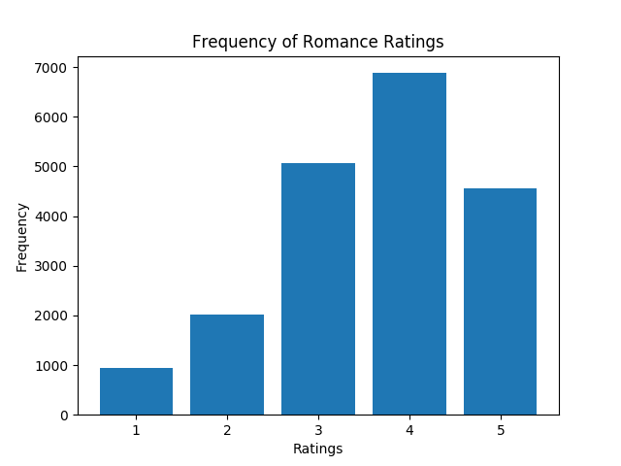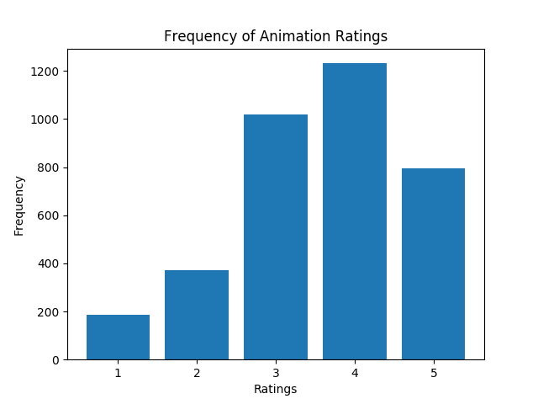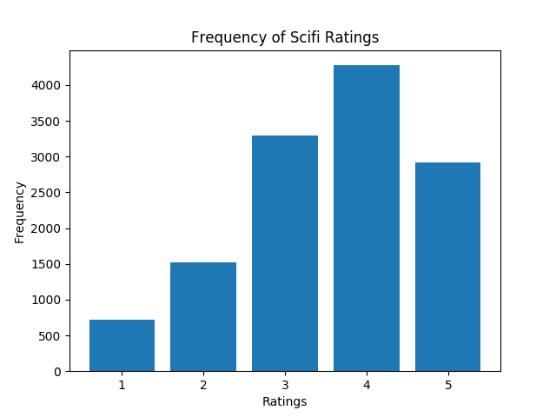

Figure 4: All ratings in the Animation, Romance, and Sci-Fi ratings.

**Matrix Factorization Methods**

***Theory***

*Model 1: Homework 5 model without bias*

Our initial method worked by minimizing the following expression by performing SGD with respect to U and V:

$${argmin}_{U,V}\frac{λ}{2}\left({\left|\left|U\right|\right|}_{F}^{2}+{\left|\left|V\right|\right|}_{F}^{2}\right)+\frac{1}{2}\sum_{i,j}{{\left(y_{ij}-{u_{i}}^{T}v_{j}\right)}^{2}}$$

This results in the decomposition of our original Y matrix consisting of M Users x N Movies into $U^{T}V$, where U is an M x k matrix and V is a N x k matrix.

*Model 2: Homework 5 model with bias*

For the bias model, we add the two terms a and b to the prior model. Hence, the model works by minimizing the following expression by performing SGD with respect to U, V, a and b:

$${argmin}_{U,V}\frac{λ}{2}\left({\left|\left|U\right|\right|}_{F}^{2}+{\left|\left|V\right|\right|}_{F}^{2}\right)+\frac{1}{2}\sum_{i,j}{{\left(y_{ij}-({u_{i}}^{T}v_{j}+a_{i}+b_{i}\right)}^{2}}$$

*Model 3: Off-the-shelf model*

The off-the-shelf method from the surprise module works by minimizing the following expression by performing SGD:

$${argmin}_{q,p}{\sum_{u,i}{(r_{ui}-{\hat{r}}_{ui}})}^{2}+λ\left({\left|\left|q_{i}\right|\right|}^{2}+{\left|\left|p_{u}\right|\right|}^{2}\right)$$

Here:

$${\hat{r}}_{ui}={q_{i}}^{T}p_{u}$$

This is essentially the same as our model 1 approach. Here the r matrix consisting of M Users x N Movies will be decomposed into qTp, where q is an M x k matrix and p is a N x k matrix. We do notice here that the derivatives of the off-the-shelf method will be slightly different (multiplied by 2) from the homework 5 mode.

Similarly, the biased version of the off-the-shelf method works by having:

$${argmin}_{q,p}{\sum_{u,i}{(r_{ui}-{\hat{r}}_{ui}})}^{2}+λ\left({\left|\left|q_{i}\right|\right|}^{2}+{\left|\left|p_{u}\right|\right|}^{2}+{b_{i}}^{2}+{b_{u}}^{2}\right)$$

Here:

$${\hat{r}}_{ui}={q_{i}}^{T}p_{u}+b_{u}+b_{i}+μ$$

Here $μ$ is the mean of all ratings, while bi and bu are the user-specific and movie-specific deviation from global bias respectively.

***Implementation methods***

We chose the same stopping conditions as in homework 5. That is the SGD will stop if the loss reduction compared to the first epoch is less than 0.0001. This induced the SGD to stop after 30 epochs. We chose $λ=0.1,$ since this was observed to perform best in homework 5. Additionally, we chose the learning rate $η=0.03$. These parameters were chosen to be the same for both our own and our off-the-shelf implementation. However, there was no option to set any stopping conditions for the off-the-shelf implementation so we let the off-the-shelf implementation run for 30 epochs (effectively the same as our homework 5 model).

The models were compared through Root Mean Squared Error (RMSE) of the test set.

We used the linalg.svd function from the numpy module in order to project V into 2D space.

***Results***

Table 1 shows the RMSE accuracy of our 3 models.

|  |  |
| --- | --- |
| **Model type** | **RMSE** |
| Homework 5 model without bias | 0.66 |
| Homework 5 model with bias ? |  |
| Off-the-shelf model with bias | 0.9143 |
| Off-the-shelf model without bias | 0.9458 |

Hence, we can see that our homework 5 model performed best compared to the off-the-shelf model. The main difference between the homework 5 model and the off-the-shelf surprise model is the difference in selecting initial values for the U, V and bias arrays. In the homework 5 model, these were initialized as values between [−0.5, 0.5]. However, in the surprise off-the-shelf implementation these are initialized randomly with the numpy random.RandomState() function. Hence the selection of initial values will be quite different for each model. This means that the step size and number of epochs should probably be selected differently and optimized for the initial values that are incorporated in the surprise off-the-shelf implementation function. Additionally, there are some slight differences in the error term and the resulting derivatives between the two equations (missing ½ and 2 constants in front of terms in the off-the-shelf implementation) that could also result in differences between the test RMSEs. Lastly, the implementation of the surprise.SVD does appear to be more customizable with several different individual step sizes and regularization terms that can be changed and optimized. The homework 5 model only has one step size and regularization. Hence, the implementation of the surprise.SVD function is generally different from the homework 5 model and require more detailed optimization of parameters.

We also observe, that the model with bias performs slightly better than the one without bias in the both the case for homework 5 and the off-the-shelf implementation. This makes sense as we have extra parameters to ensure a more flexible fit to the data. This prevents underfitting.

***Data Visualization graphs***

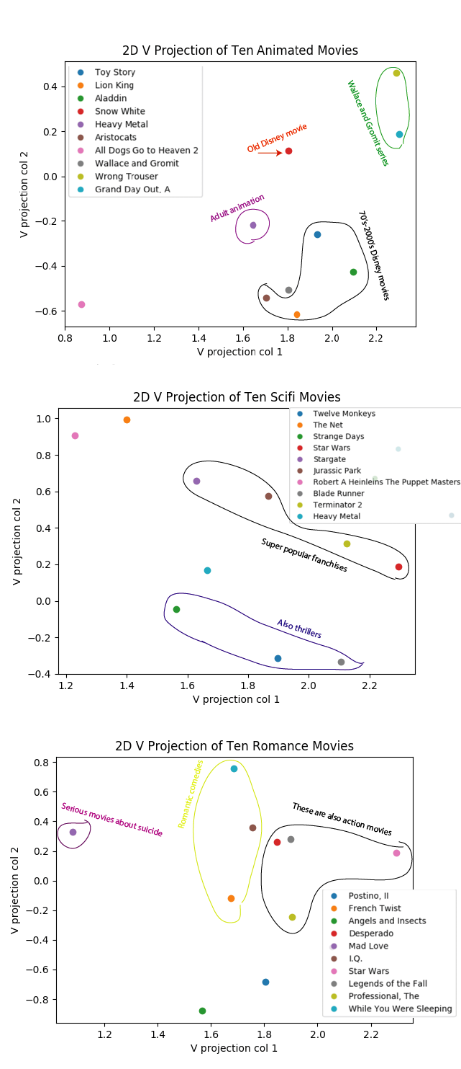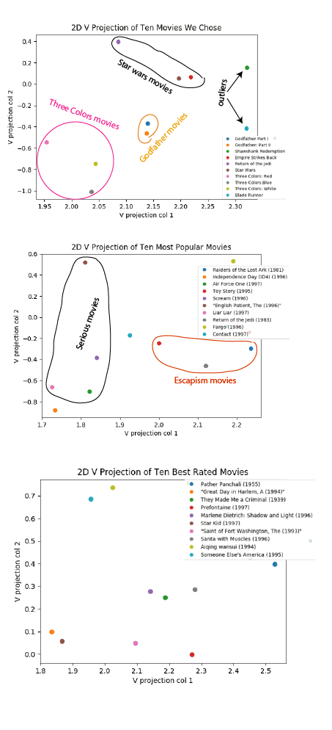

Figure 5: Plots of 10 random movies, 10 most popular movies, 10 best movies, 10 movies from the Anime, Sci-Fi, and Romance genres using the homework 5 model with no bias.

Figure 7: Plots of 10 random movies, 10 most popular movies, 10 best movies, 10 movies from the Anime, Sci-Fi, and Romance genres using the off-the-shelf implementation. We also have 2 extra graphs showing the comparison between popular and best movies as well as movies from the three genres.

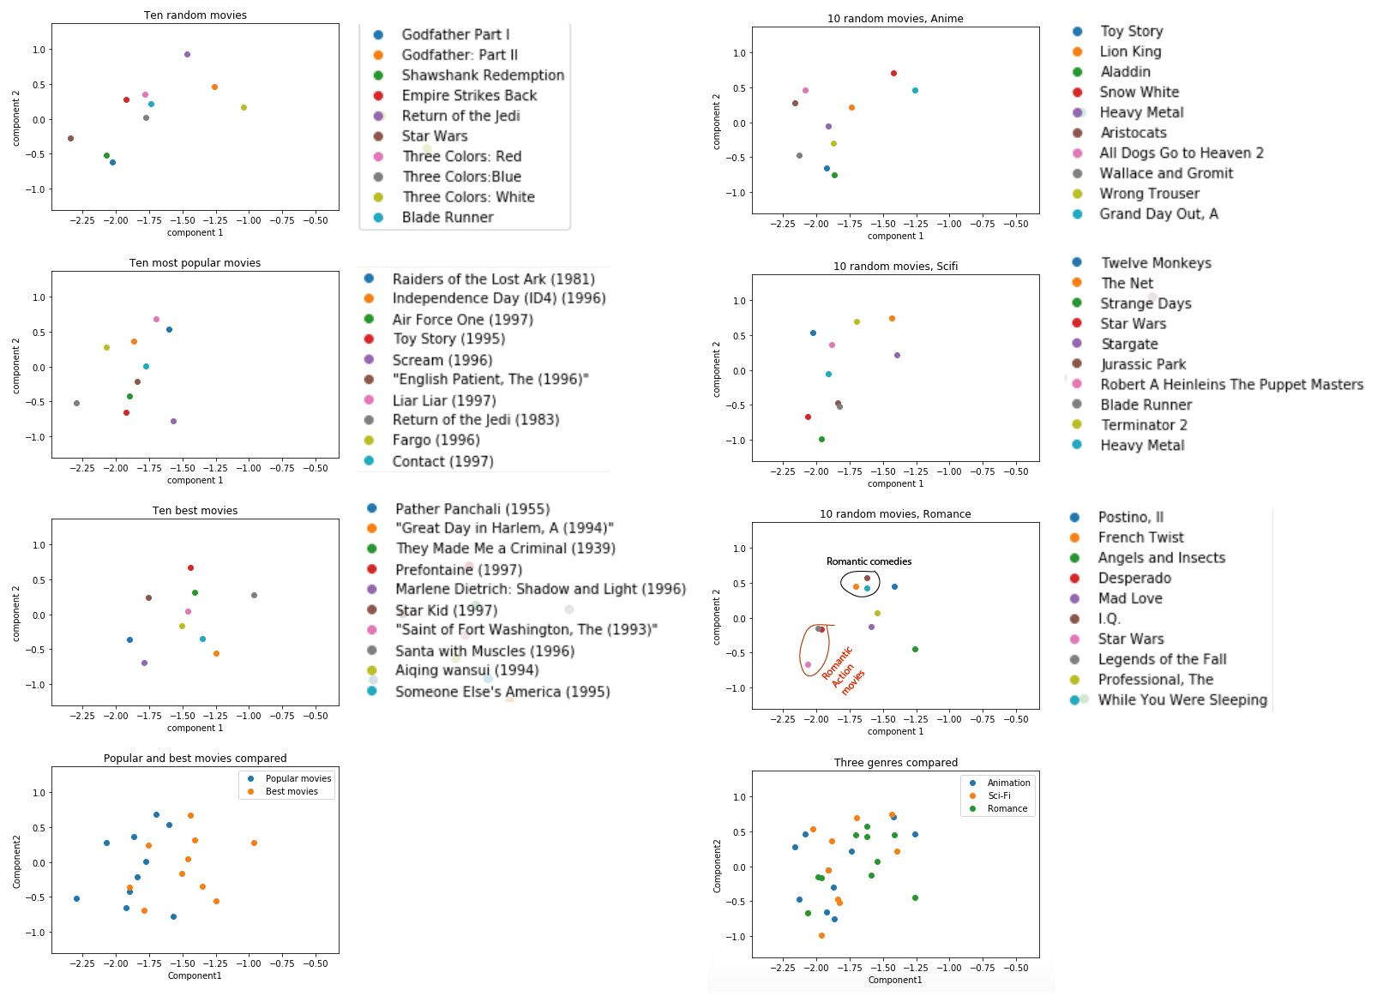

**Matrix Factorization Visualizations**In order to compare expectations to results for the 10 best movies, we have compiled a table of themes/plots in the 10 best movies, since they were all unknown to us (Appendix A).

***Homework 5 model, no bias:***Fig. 5 shows the 10 random, 10 most popular, and 10 best movies from using the homework 5 model with no bias. For the 10 random movies, we can observe that movies that are in the same movie series group together, e.g. the 3 Star Wars movies, the 2 Godfather movies, the 3 Three Colors movies. The outlier movies, Blade Runner and Shawshank Redemption also appear to be outliers in the V component 1 and component 2 space. These patterns are what we expected for the 10 random movies that we chose. We can also see that Sci/Fi and action movies generally have high values for the first component/column of V, while the Three Colors movies that are more serious movies about dealing with emotions. This could reflect a trend in viewers that might reflect gender and/or education level/type/social-economic groupings. This is also observed in the plot for 10 most popular movies. Here we observe that escapist movies (e.g. Last Jedi, Raiders of the Lost Arc, and Toy Story) have high values for V component 1 while serious movies (e.g. English Patient, Air Force 1, and Liar Liar have low values for V component 1. This is to be expected as well. We observe that the 10 best movies generally have a high value for the V component 2 compared to most popular movies, and therefore appear to be distinct. We could not find any individual groupings within 10 best movies. This is probably due to the fact that few people have rated these movies. Hence, we are not pulling out a lot of information on them.

Fig. 5 shows 10 movies from the Animation, Sci-Fi, and Romance genres from using the homework 5 model with no bias. We can see that animation movies appears to plot with a relatively low value of the second component/column of V compared to Sci-Fi and Romance movies. This could reflect a younger age of the animation movies audience. This suggests that the second component/column of V might reflect ages. The Sci-Fi movies generally have high values for the second component/column of V which might reflect an older audience. This is to be expected since age groupings are a very significant part of audience ratings and target groups. We can also see that movies that come from a similar company structure group together. For example, Disney movies group together and Wallace and Gromit movies group together. Super popular Sci-Fi franchises (e.g. Jurassic Park, Star Wars, Terminator, Stargate) group together. This is also to be expected since similar attributes in movies (e.g. large franchise, Disney) may be preferred by the same audience groups. Additionally, movies in each category that also share another genre appear to group together as well. In particular, we observe that Sci-Fi movies that are also thrillers group together. Additionally, Romance movies that are also action movies group together, while Romance movies that are also comedies group together. This is also to be expected since those movies would be more similar to each other and probably liked/disliked by the same type of people.

In general, there seems to be a slight trend suggesting that more serious and lesser known movies have a low value for the first component/column of V while big action movies/fanchises/animation movies that might be more light-hearted and appealing to the masses have a high value for the first component/column of V. This would also be expected because it could reflect education level or some sort of social group distinction.

Surprisingly, there doesn’t seem to be any trends related to gender, which we would have expected

***Homework 5, with bias:***

***Surprise off-the-shelf implementation***Fig. 7 shows 10 random movies, 10 most popular movies, and 10 best movies from using the off-the-shelf implementation. We observe that with the off-the-shelf implementation, the Star Wars, Godfather, and Three Colors movies do not cluster together. We would not expect this because they are part of the same franchise and would likely have the same viewer base. We do observe that the 10 best movies have higher values for the V component 1 compared to the 10 most popular movies. This could maybe reflect that many people watch the popular movies and few people watch the “best” movies. We would expect the best movies and popular movies to plot differently in the 2D V space, since the popular movies targets a broad audience while the “best” movies seems to be movies that target a very niche segment. Other than that the off-the-shelf algorithm is not picking up any particular trends for the 10 random, most popular, and best movies.

Fig. 7 shows 10 movies from the genres Animation, Sci-Fi, and Romance from using the off-the-shelf implementation. We see that the off-the-shelf implementation is not as good as picking up the component trends with genre, age, and serious/light-hearted type of movies trends. In addition, the algorithm is not as good at picking up the trends related to company, franchises, and subgenres as the previous algorithms were. In general, the three different genres appear to be plotted in a similar range for V component 2 and 1, and we don’t see any particularly groupings. This would not be what we expect.

***Comparison of 3 models***A summary figure of the discussion of the models show that the plots can approximately be interpreted like Fig. 8, although there are many outliers to this plot. This plot was reflected well in the homework 5 models with bias and without bias. Similar? However, this was not reflected well in the off-the-shelf surprise model. The off-the-shelf surprise model also had quite a high RMSE compared to the two other models. This suggests that the model might not fit well to the MovieLens data set, and therefore we are not able to pick out any of the observed trends.

Figure 8: Summary figure of the 2D space



**Appendix A**

Table : Overview of themes/Plots in the “10 Best Movies”

|  |  |  |
| --- | --- | --- |
| **Movie Name** | **Theme/Plot** | **Genres** |
| Pather Panchalli | Lower social class in India | Drama |
| Great day in Harlem | Documentary about a photograph of jazz musiscians | Documentary |
| They made me a criminal | Film-noir movie from the 30’s about a boxer who (maybe) committed a murder | Drama, crime |
| Prefontaine | Documentary about Steve *Prefontaine,* long-distance runner | drama |
| Marlene Dietrich | Documentary about Marlene Dietrich | documentary |
| Star kid | Sci-fi movie about young boy | Children, fantasy, scifi, adventure |
| The Saint of Fort Washington | Movie about homeless schizophrenics | Drama |
| Santa with Muscles | Comedy about millionaire who thinks he is santa clause | comedy |
| Aiquing Wansui | Taiwanese erotica movie | Drama |
| Someone Else’s America | Comedy about two Spanish men and reaching the American Dream | Drama |